Supporting information (SI)

Appendix S1: Selection of arthropods for C:N analysis

We selected two broad functional groups to evaluate the differences in % nitrogen among native and non-native plants. Spiders (Araneae) were selected as indicators of the %N content of the third trophic level as arthropod predators. Our other function group were insect herbivores. We selected insect herbivores from families that were most likely to feed on plant foliage, particularly the foliate of woody plants included in our experiment. These represent the nutritional content of insect prey primarily available to bird and the numerical majority of arthropods collected. Insect herbivore families selected included: All families of Lepidoptera collected (primarily Geometridae and the superfamily Noctuoidea), Hemipteran families including Tingidae, Miridae, Coreidae, Pentatomidae, Acanthosomatidae, and Thyreocoridae. We included sawfly families Cimbicidae and Tenthrediniadae. The only beetle families selected were those likely to feed on foliage as adults or larvae, including Brentidae, Chrysomelidae, Cleridae, Curculinidae (only the subfamily Entiminae) and Melolonthinae.

Figure. S1. Average abundance of aquatic insects (# per bagged branches) among ten sampled host-plant species. Bar height indicates estimated mean from GLMM, and error bars indicate 95% confidence intervals. Bars with non-overlapping confidence intervals are significantly different. Bars ranked by estimated means.

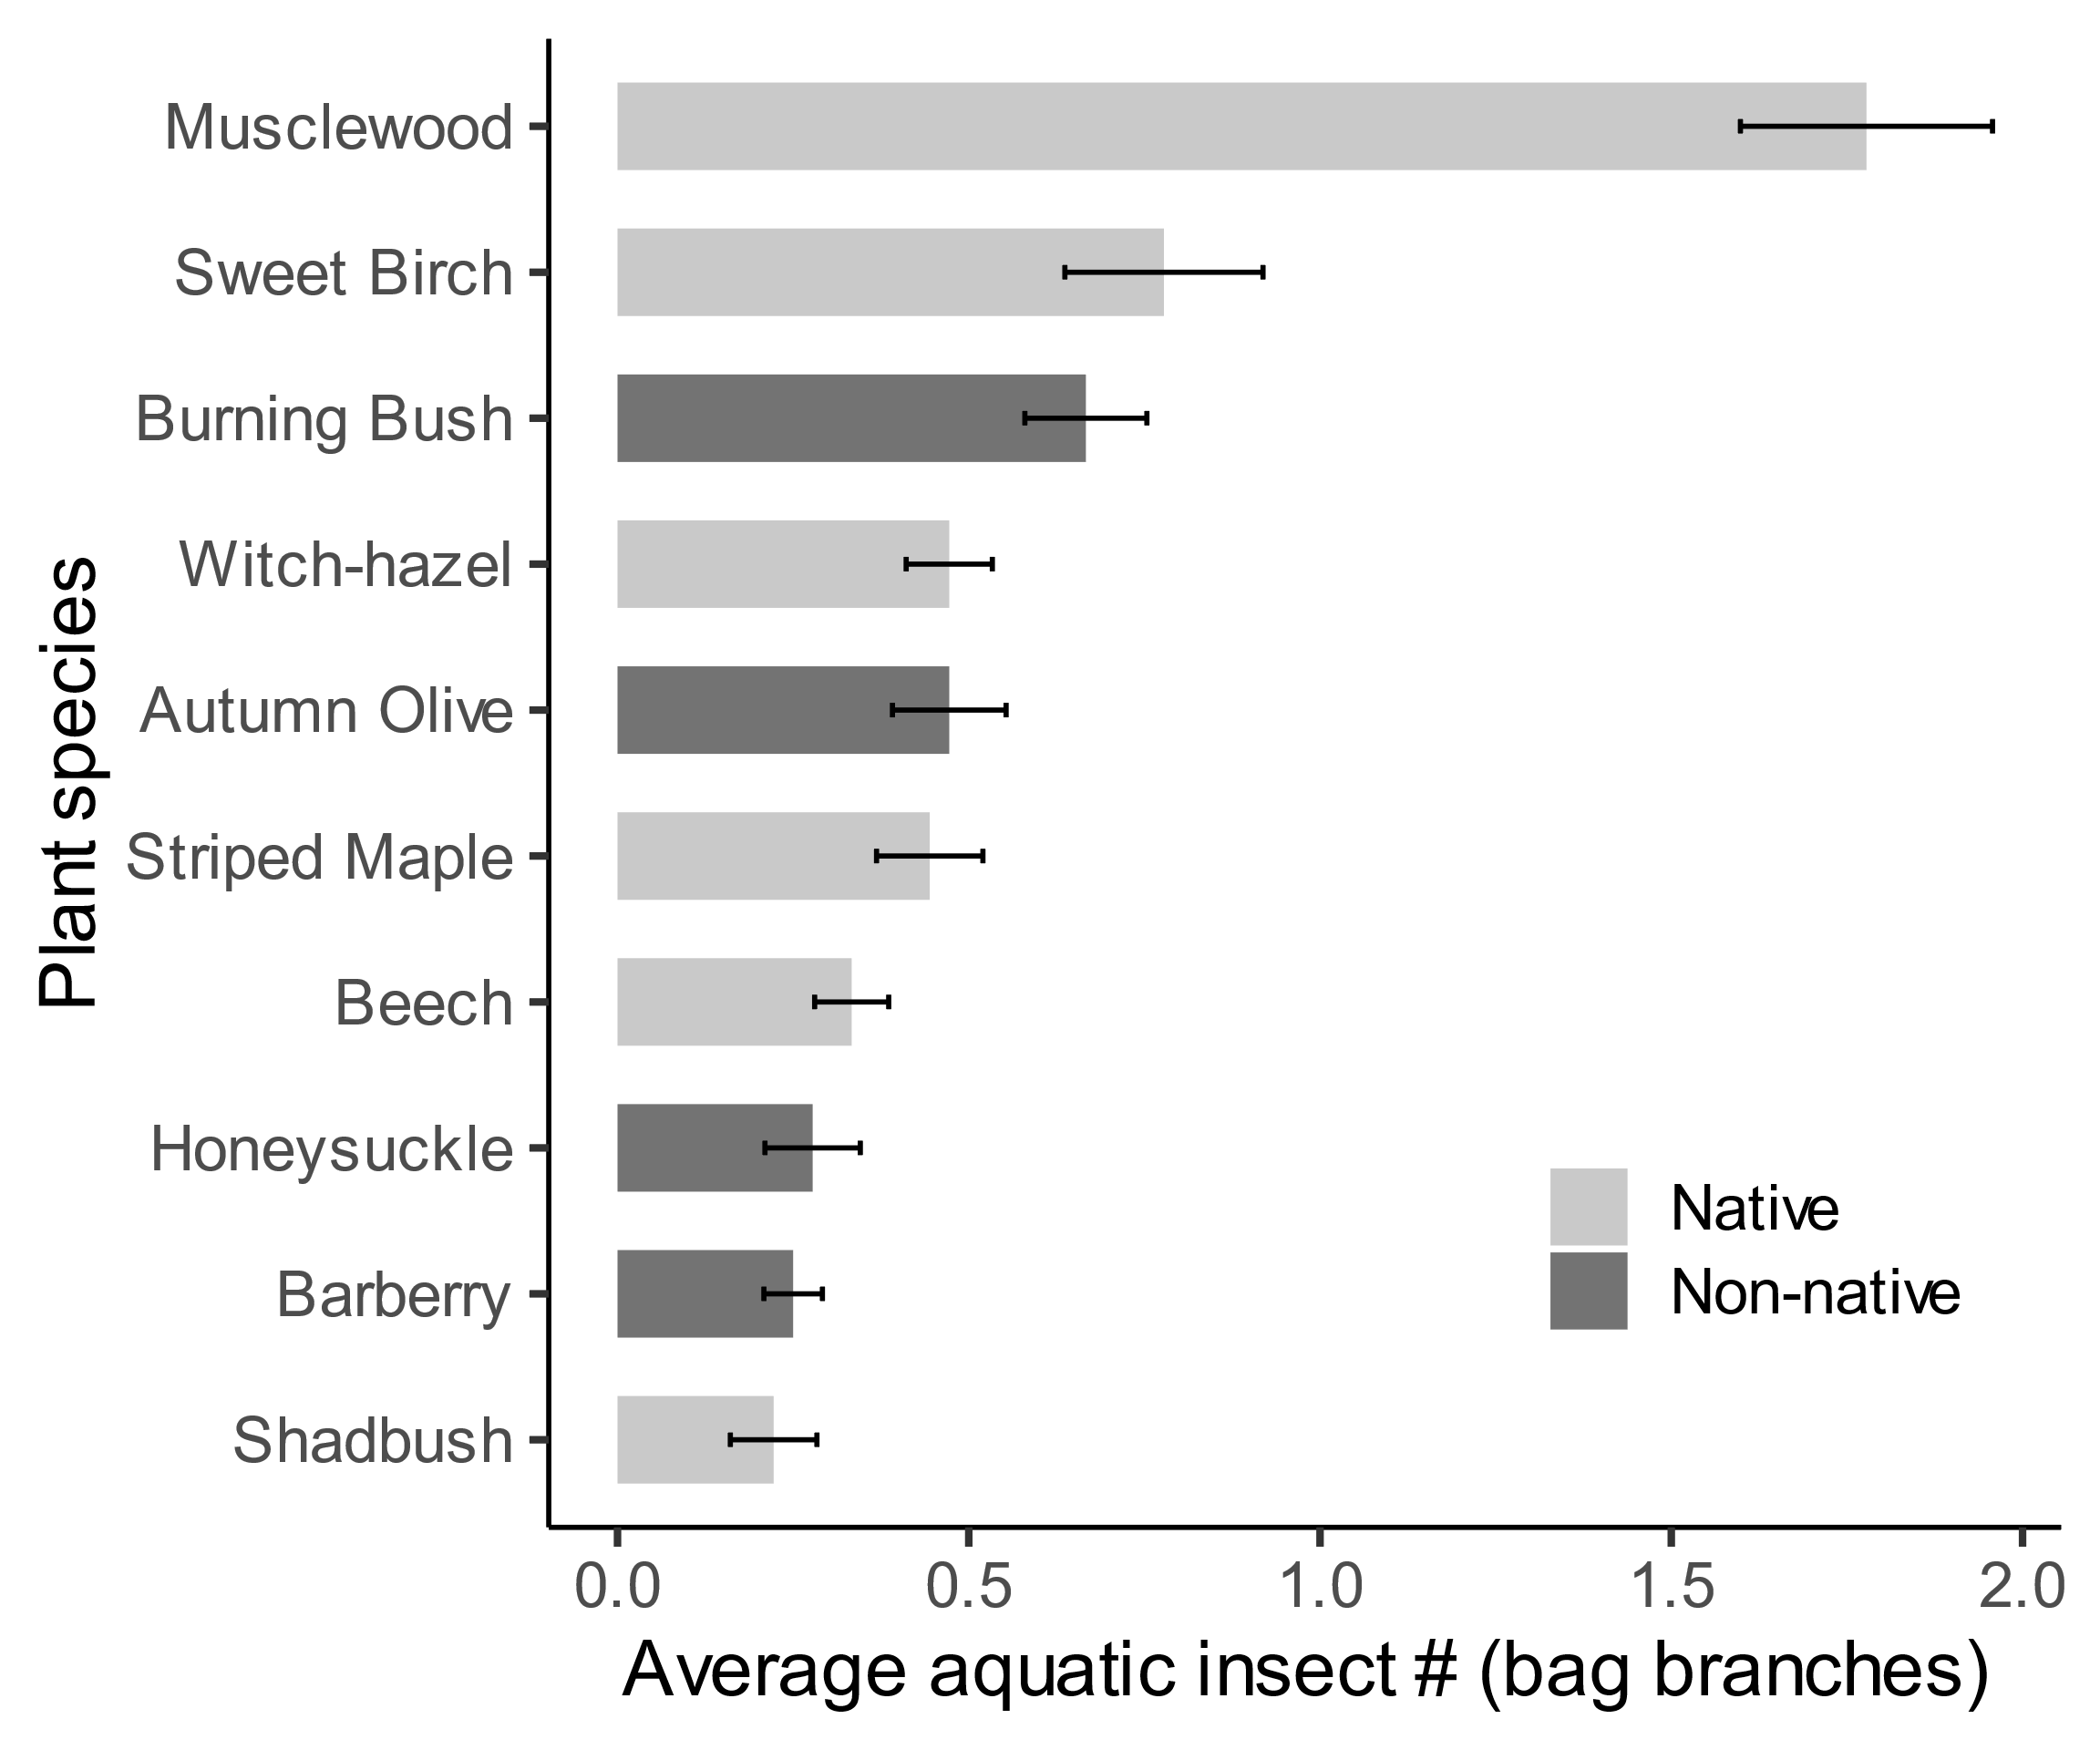

Fig. S2. Average abundance of lepidoptera (# of caterpillars per bagged branches) among ten sampled host-plant species. Bar height indicates estimated mean from GLMM, and error bars indicate 95% confidence intervals. Bars with non-overlapping confidence intervals are significantly different. Bars ranked by estimated means.

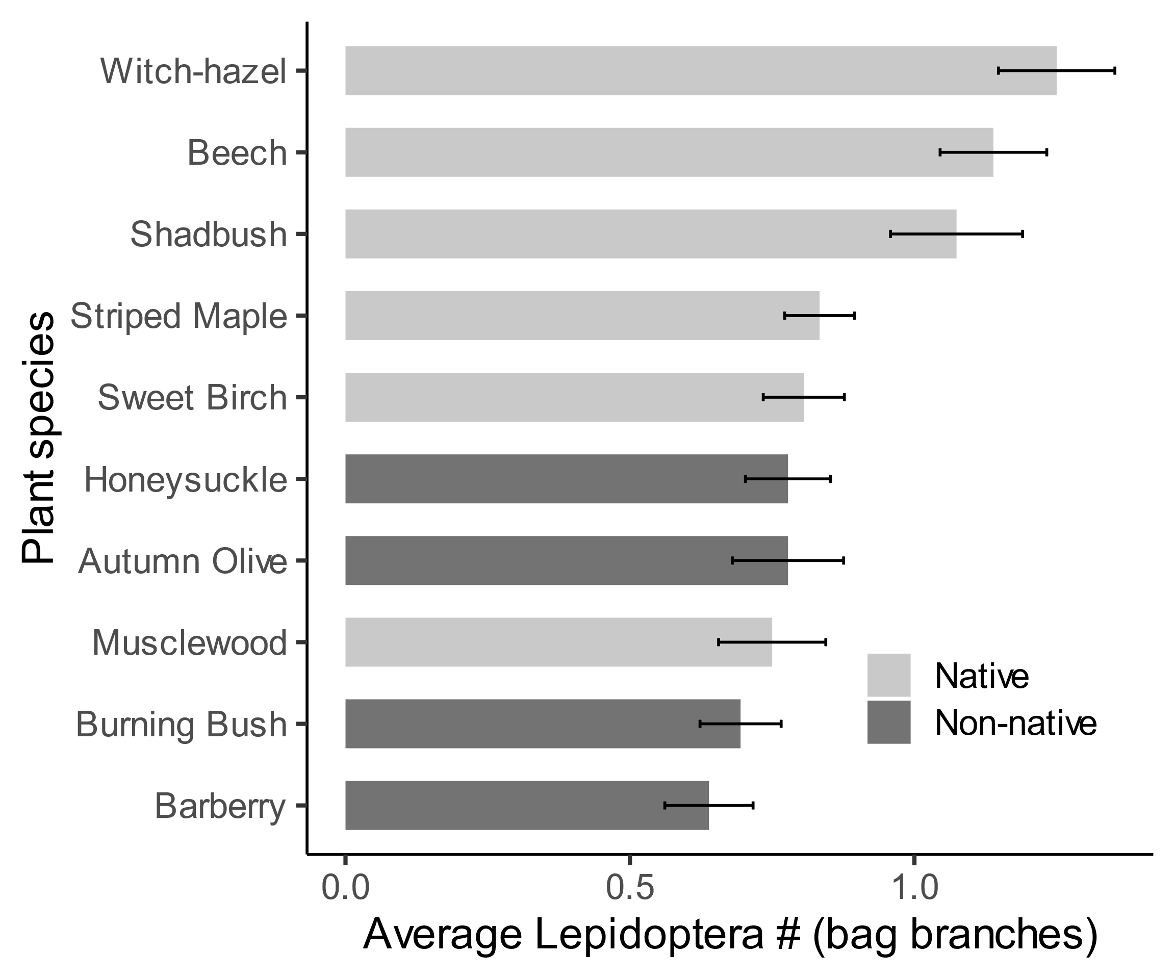

Fig. S3. Average abundance of spiders (# of spiders per bagged branch) among ten sampled-host plant species. Bar height indicates estimated mean from GLMM, and error bars indicate 95% confidence intervals. Bars with non-overlapping confidence intervals are significantly different. Bars ranked by estimated means.

